MED D - Low Income Subsidy (LIS) Informational Overview

Overview
LIS Level – SCEs for Changes in Subsidy Level
LIS Levels
LIS Enrollees
Checking LIS Status
SilverScript Self-Funded EGWP - Low Income Premium Subsidy Refund Checks
LIS FAQ
Related Documents

Description: This document is to provide MED D Customer Care Representatives (CCRs) with a general overview of Low Income Subsidy (LIS), also known as Extra Help, in order to prepare them to address questions from MED D beneficiaries regarding this program.

Overview

The Social Security Administration determines Low Income Subsidy (LIS) for qualified beneficiaries in order to assist them with expenses for prescription drug costs.
- This is also known as Extra Help.
- The Extra Help may pay for:
  - The monthly premium
  - Annual deductible
  - All or part of the cost-sharing
- LIS is regulated by the government, and some beneficiaries must apply and subsequently qualify for LIS.
- If beneficiaries fall under the following categories, they are deemed LIS and do not need to apply:
  - Recipients who receive Supplemental Security Income
  - Eligible for Medicare Savings Program
  - Eligible for full Medicaid benefits
- When a beneficiary is approved for LIS, the Social Security Administration determines the beneficiary’s LIS cost sharing level and notifies CMS.
  - The LIS level determines the amount of Extra Help the beneficiary will receive and any cost-sharing.
- CMS will notify the plan of the beneficiary’s LIS level
- SSA conducts annual redeterminations for some beneficiaries who currently receive LIS in order to determine if they will qualify for the following benefit year. Not everyone is reviewed every year.

Top of the Document

LIS Level – SCEs for Changes in Subsidy Level

The following six Subsidy Changing Events (SCEs) may result in a change in LIS eligibility or the beneficiary LIS level when they are reported. The Social Security Administration will review eligibility for the program on an annual basis.

- Marriage
- Death of living-with spouse
- Divorce from living-with spouse
- Annulment from living-with spouse
- Separation from living-with spouse
6. Resumption of living together with previously separated spouse

Additionally, there are other factors that may result in the SSA recalculating a change in the Extra Help amount. SSA conducts the redetermination process annually.

Examples of Other Events include the following:
- Beneficiary reports a change in household
- Beneficiary reports stop work and change in income
- Beneficiary reports change in resources

Top of the Document

LIS Levels

There are three Low Income Subsidy levels or categories.
- The cost sharing for LIS levels are updated each year.
- Below are the 2025 vs. 2024 Low-Income Subsidy premiums and cost-sharing.

To review how LIS levels affect what a beneficiary pays on SilverScript and NEJE plans, refer to the following documents:

- MED D - 2025 SilverScript PDP Readiness Plan Design Reference
- MED D - 2024 Readiness Plan Design Reference
- MED D - Blue MedicareRx (NEJE) 2025 AEP Readiness
- MED D - Blue MedicareRx (NEJE) 2024 AEP Readiness

 |  | 2025 | 2024
LIS Category 1  LIS eligible Beneficiaries with Incomes between 101% and 150% of Federal Poverty Level (FPL) | Premium | 100% premium assistance. However, if the beneficiary selects a plan with a premium above the benchmark premium for their state, the beneficiary will be responsible for the remainder. | 100% premium assistance. However, if the beneficiary selects a plan with a premium above the benchmark premium for their state, the beneficiary will be responsible for the remainder.
 | Deductible | $0 | $0
 | Generic/Preferred Drugs | $4.90 | $4.50
 | Other | $12.15 | $11.20
 | Above Out-of-Pocket Threshold | $0 | $0
 |  | 2025 | 2024
LIS Category 2  LIS eligible Beneficiaries with Incomes up to 100% of the Federal Poverty Level (FPL) | Premium | 100% premium assistance. However, if the beneficiary selects a plan with a premium above the benchmark premium for their state, the beneficiary will be responsible for the remainder. | 100% premium assistance. However, if the beneficiary selects a plan with a premium above the benchmark premium for their state, the beneficiary will be responsible for the remainder.
 | Deductible | $0 | $0
 | Generic/Preferred Drugs | $1.60 | $1.55
 | Other | $4.80 | $4.60
 | Above Out-of-Pocket Threshold | $0 | $0
 |  | 2025 | 2024
LIS Category 3  LIS eligible Beneficiaries are institutionalized or would be institutionalized if they were not receiving home and community-based services. (HCBS) | Premium | 100% premium assistance. However, if the beneficiary selects a plan with a premium above the benchmark premium for their state, the beneficiary will be responsible for the remainder. | 100% premium assistance. However, if the beneficiary selects a plan with a premium above the benchmark premium for their state, the beneficiary will be responsible for the remainder.
 | Deductible | $0 | $0
 | Generic/Preferred Drugs | $0 | $0
 | Other | $0 | $0
 | Above Out-of-Pocket Threshold | $0 | $0

Top of the Document

LIS Enrollees

Full Benefit Dual-Eligible Enrollees (FBDE)
Low-income beneficiaries who are enrolled in both Medicare and Medicaid are known as Full Benefit Dual Eligible Enrollees.
- Full Benefit Dual-Eligible Enrollees are automatically enrolled into a Prescription Drug Plan (PDP) by CMS.
  - NOT all LIS participants are Full Benefit Dual-Eligible Enrollees.
  - FBDE Enrollees qualify for a subsidy of Medicare and Medicaid costs.

Auto Enrollment
- CMS will enroll beneficiaries and Auto-Enroll each year if their current plan is going to have a premium above the benchmark. If not, the beneficiary stays in their current plan.

Facilitated Enrollment
- CMS facilitates enrollment of certain LIS beneficiaries into PDPs. This population is separate from the individuals auto assigned into a PDP.
- If an individual is facilitated into a PDP, their coverage will start two months after CMS receives notice of their eligibility.
- Facilitated Enrollment is the process by which other LIS beneficiaries who are eligible for the low-income subsidy are enrolled in a Part D plan.
- Other LIS eligible individuals are defined as:
  - Those deemed automatically eligible for LIS because they are eligible only for Medicaid payment of Medicare Part A and/or B premium and/or cost-sharing (Medicare Savings Program)
  - SSI-only (Medicare and Supplemental Security Income (SSI), but no Medicaid)
OR
  - Those who apply for LIS at the Social Security Administration or State Medicaid Agency and are determined eligible for LIS.

Choosers
Choosers are beneficiaries who have Low Income Subsidy (Extra Help) and chose their own PDP. CMS does not reassign them into a PDP.

Enhanced Wrap Benefit
- LIS does NOT apply to Enhanced Wrap Benefit.
- LIS copays only apply to Medicare Part D plans (primary).
- If the medication is not covered through Medicare Part D, the beneficiary will be responsible for copay based on the supplemental plan.

Health Plan or EGWP Enrollees
If a beneficiary is part of a Health Plan or an EGWP beneficiary AND under LIS category 1, 2 or 3, they are NOT subject to the deductible.

Top of the Document

Checking LIS Status

MED D CCRS can view the LIS level for a beneficiary in the Participant Inquiry tab in PeopleSafe:

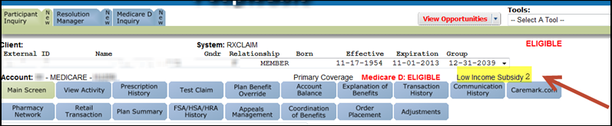
Figure A

YOU ARE REQUIRED TO CHECK MARx for the beneficiary’s LIS Status. IF YOU DO NOT HAVE ACCESS TO MARX, Warm transfer to the SENIOR TEAM. Refer to MED D - Guide to Transferring a Call.

Perform the following:
1 | Log into MARx.  Refer to Logging into MARx section of the Med D – Accessing MARx work instruction.
2 | Under the Eligibility menu, access the beneficiary’s profile.  Refer to Viewing Medicare Eligibility Information in MARx section of the MED D - Verifying Enrollment, Eligibility and LIS in MARx work instruction.
3 | Scroll down to the Low Income Subsidy Status section.  Refer to the Interpreting Medicare Eligibility Information in MARx section of the MED D - Verifying Enrollment, Eligibility and LIS in MARx work instruction.
4 | Determine the beneficiary’s current Low Income Subsidy level.
4 | If LIS Information... | Then…
4 | Is displayed in MARx AND matches what is displayed in PeopleSafe | Our records currently match what is on file with SSA/CMS.  CCR Process Note: If the beneficiary has documentation showing a different LIS Level has been awarded, ask the beneficiary to fax the documentation to fax number 1-866-552-6205.
4 | Is displayed in MARx AND DOES NOT match what is displayed in PeopleSafe | Determine who handles eligibility by reviewing the CIF eligibility section.
4 |  | If eligibility is … | Then…
4 |  | Handled by Caremark | Transfer to the Senior Team to update account to match MARx.  Refer to MED D - When to Transfer Calls to the Senior Team and PeopleSafe - Basic Call Handling (Greet, Warm, Cold, Call Hold and Close Call) .
4 |  | NOT handled by Caremark | CCR should follow the steps outlined in CIF for eligibility.
4 | Is NOT displayed in MARx | Determine who handles eligibility by reviewing the CIF eligibility section.
4 | Is NOT displayed in MARx | If eligibility is … | Then…
4 | Is NOT displayed in MARx | Handled by Caremark | I have reviewed your Low Income Subsidy information in CMS’ systems and no Low Income Subsidy is on record for you. If you have documentation showing you qualify for Low Income Subsidy, fax the documentation to fax number 1-866-552-6205.  - If no documentation is available, you or your legal representative will need to contact the SSA at 1-800-772-1213, 8 a.m. to 7 p.m. Local Time, Monday-Friday.  - TTY users should call 1-800-325-0778.
4 | Is NOT displayed in MARx | NOT handled Caremark | CCR should follow the steps outlined in CIF for eligibility.

Top of the Document

SilverScript Self-Funded EGWP - Low Income Premium Subsidy Refund Checks

Around the 25th of each month, select SilverScript Self-Funded - EGWP beneficiaries are sent a low-income premium (extra help) refund check based on the client’s direction. CCRs will not have any visibility to these refunds in PeopleSafe or FACETS. In the event, the beneficiary has questions regarding their refund check, reissue of the check(s), open an RM task:

Step | Action
1 | Open the RM task:  Task Category: Retail  Task Type: Research/Reissue/Stop Payment  Queue: Member Payment
2 | Ask the beneficiary:  If, upon a review of your account, we determine that additional checks are outstanding, do we have your permission to reissue those check(s) as well?  Add a note to the task for the appropriate response: “Yes, member approves to reissue all outstanding checks” or “No, the member only wants this specific check(s) to be reissued”

Note:
- Check cannot be requested/reissued to the same address until 30 days after the original mailing date. (Example: April refund check mails on 04/25, a replacement can be requested on 05/25.)
- When CMS notifies the plan that an enrollee is deceased and eligibility shows an end date in PeopleSafe, the subsidy refund checks will no longer be issued.

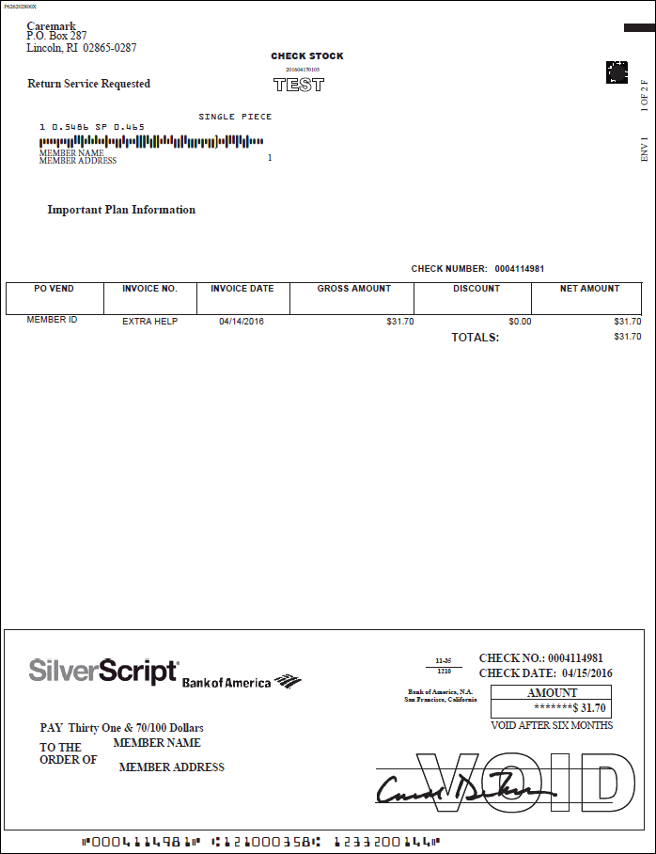
Sample Check

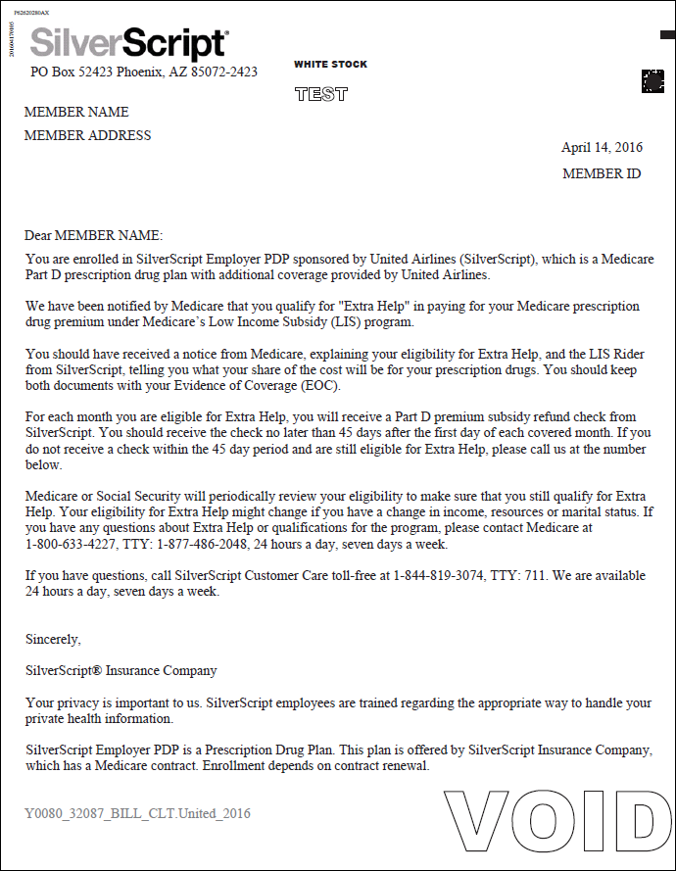
Sample Letter

Top of the Document

LIS FAQ

Use as needed:
Question | Answer
Does LIS apply to Enhanced Wrap Benefit? | - No. LIS copays only apply to Medicare Part D plans (primary).  - If the medication is not covered through Medicare Part D, the beneficiary will be responsible for copay based on the supplemental plan.
Does a beneficiary’s LIS qualification change at any time? | - A beneficiary’s qualification may change due to one of the six Subsidy Changing Events during the year.  - As part of an annual process, the Social Security Administration determines if beneficiaries who qualified for Extra Help paying for Medicare prescription drug coverage in the current year will continue to qualify the following year.  - There may be Other Events, such as change in income, change in resources and change in size of household that may impact a beneficiary’s Extra Help. These are subject for review and evaluated on a case-by-case basis.
What factors affect beneficiaries who currently automatically qualify for Extra Help? | - Some beneficiaries who automatically qualify for Extra Help in the current year will no longer automatically qualify in the following year.  - Beneficiaries who no longer have both Medicare and Medicaid (full-benefit dual-eligibles), belong to Medicare Savings Programs (partial dual eligibles), or get Supplemental Security Income (SSI) benefits will no longer automatically qualify for Extra Help.  - These beneficiaries will need to apply to Social Security or their State Medical Assistance (Medicaid) office to see if they still qualify for Extra Help based on their income and resources.  - Other beneficiaries will continue to automatically qualify for Extra Help in the current year, but their co-payment levels will change.  - The change in co-payment level could result from a change in their Medicaid eligibility.  Example:  They may have had a change from one of the following categories to another:  - Having Medicare and Medicaid and residing in an institution  - Having Medicare and Medicaid  - Belonging to a Medicare Savings Program  - Receiving SSI benefits but not Medicaid
How will a beneficiary know if they no longer automatically qualify for Extra Help? | - Beneficiaries who will no longer automatically qualify for Extra Help in the upcoming plan year will receive a grey letter from CMS in late September.  - The letter includes a paper application to apply for Extra Help to Social Security and a pre-addressed postage-paid envelope.  - Individuals should apply to determine if they still qualify for Extra Help.
What should a beneficiary do if they no longer automatically qualify for Extra Help in the following year? | - Beneficiaries who no longer automatically qualify for Extra Help should apply to Social Security or their State Medical Assistance (Medicaid) office as soon as possible to see if they still qualify for Extra Help based on their income and resources.  - If a beneficiary’s situation changes so that they again automatically qualify, CMS will send another purple notice, letting the individual know that they qualify.  - Beneficiaries who no longer qualify for Extra Help should look at other options that may help pay their drug costs, including available State and local programs.  - They may also want to compare available Medicare drug plans to their current Medicare drug plan to see if they can save money.  - When comparing plans, beneficiaries should check to make sure the plan covers the prescriptions they take and includes the pharmacies they use.  - Beneficiaries can call their State Health Insurance Assistance Program (SHIP) for free personalized counseling about their choices.  - Refer to MED D - SHIP Counselor Calls For CVS Caremark Part D Plans.
How will beneficiaries know if their copayment amounts will change in the upcoming plan year? | - Beneficiaries whose copayment amounts will change as of January 1 will receive an orange letter from CMS in October letting them know their new copayment amounts.
What should a beneficiary do if they think there’s been a mistake determining their eligibility for Extra Help? | - For any questions, beneficiaries could call 1-800-MEDICARE (1-800-633-4227).  - TTY users should call 1-877-486-2048.  - Callers who report that they are still Medicaid eligible will be directed to their State Medicaid Agencies.
What is the process SSA uses for beneficiaries who do not automatically qualify for Extra Help but applied and qualified for Extra Help? | - The Social Security Administration reviews the eligibility of beneficiaries who apply and qualify for Extra Help.  - Social Security mails notices to these beneficiaries letting them know that Social Security shows a change in their income (not including cost of living increases), resources, and household size  - Beneficiaries who don’t have changes to their income, resources, or household size will have to indicate on the form that no changes occurred and return the form within 30 days.  - Beneficiaries who have any changes to their income, resources, or household size will need to return a one-page letter to Social Security within 30 days to explain the changes.  - Social Security will then mail a form for them to fill out and return called Social Security Administration Review of Your Eligibility for Extra Help (Form 1026-SM-REDE).  - Social Security will also send the eligibility review form (Form 1026-SM-REDE) directly to some beneficiaries to complete because Social Security has information that there was a change in income or resources.  - This form needs to be returned within 30 days.  - Social Security will review the eligibility review form (Form 1026-SM-REDE) and send the beneficiary a letter explaining its decision.  Social Security may decide a beneficiary:  - Has no change in the amount of Extra Help they receive, or  - Has an increase in the amount of Extra Help they receive, or  - Has a decrease in the amount of Extra Help they receive, or  - No longer qualifies for Extra Help
What if a beneficiary doesn’t agree with Social Security’s decision? | - Beneficiaries have the right to appeal if they disagree with Social Security’s decision.  - The decision letter they get from Social Security will explain their appeal rights.
Will everyone with Extra Help get a letter from Medicare or Social Security? | - Beneficiaries who continue to automatically qualify for Extra Help in the following plan year will receive a letter from Social Security.
Where can beneficiaries get more information about applying for Extra Help? | - Beneficiaries who have questions about filling out the application for Extra Help should visit www.socialsecurity.gov on the web or call Social Security at 1-800-772-1213.  - TTY users should call 1-800-325-0778.
Are Medicare letters available in non-English languages upon request? | - To request a translation of the notice, beneficiaries can call 1-800-MEDICARE (1-800-633-4227).  - TTY users should call 1-877-486-2048.

Top of the Document

Related Documents

Parent SOP: CALL-0048: Medicare Part D Customer Care Call Center Requirements-CVS Caremark Part D Services, L.L.C.
Abbreviations/Definitions: Abbreviations / Definitions

Top of the Document

Not to Be Reproduced or Disclosed to Others without Prior Written Approval
ELECTRONIC DATA = OFFICIAL VERSION - PAPER COPY = INFORMATIONAL ONLY

